2025-26 Fall

CMPE/ISE 494 Senior Project Report

VIRTUAL COMBAT SYSTEM

Project Short Title | VCS
Project Full Title | Virtual Combat System
Subject Classification | Military Simulation
Student name(s)  (Team members of project) | Seda KOCAOĞLU, Mert KAVİLCİOĞLU
Full Name of Corporation | HAVELSAN HAVA ELEKTRONIK SAN. VE TIC. A.Ş
Mentor Name(s)  (Corporation member) | Bertan BUYURAN
Coordinator Name(s)  (University member) | Gökhan ŞENGÜL, Sacip TOKER

Abstract
Communications and acknowledgments are done with Tactical Data Link (TDL) systems in the military area. Tactical Data Link is a secure, standardized communications system, which used RF to communicate, used by military forces to transmit real-time data, like location, platform information between platforms such as aircraft, ships, ground vehicles, and command centers. There are different link systems for these communications used by NATO and approved partners. The need for these systems was realized when soldiers on their own had limited environmental awareness and needed rapid communication with each other and other ally platforms to increase their environmental awareness. In the absence of a rapid communication and information system, in times when rapid action is required, such as in a war situation, it is almost impossible for soldiers to distinguish friend from foe with insufficient information.
Although TDL studies were rapidly progressing, it was almost impossible to test the results in real life most of the time because of the cost and time required. So, people came with the idea of developing simulations which simulate the communication between ally units. Different simulations are being developed for this purpose, and in this project, it is observed and inspired by a project currently being developed at HAVELSAN with the permission and approval of the developers.
In this version of the project, it is aimed to create a simple-looking simulation that would be user-friendly and would allow users to easily simulate communication and play different scenarios. For that Java and JVM used for developing engine and Java Swing used for user-friendly UI. With this project, the main goal was to create a cheaper testing environment where new and different scenarios can be easily tested and that will benefit users.
Keywords: Military Simulation, Link 16, Tactical Data Link, Simulator Engine, Java

Table of Contents
Abstract 2
Keywords: Write at least 5 keywords (separated by commas) describing your work 2
Ch1: Introduction 0
1.1 Problem Statement 0
1.2 Scope 0
Ch2: Project Plan 1
2.1 Methodology 1
2.2. Time Schedule (Gantt Chart) 2
2.3. Deliverables List 3
Ch3: Literature Review 4
Ch4: Requirements 8
4.1 Overall Description of the Project 8
4.1.1 Product Perspective 8
4.1.2 Product Functions 8
4.1.3 User Characteristics 8
4.1.4 Constraints 8
4.1.5 Assumptions and Dependencies 9
4.2 Specific Requirements 9
4.2.1 External Interface Requirements 9
4.2.2 Functional requirements 10
4.2.3 Quality Requirement (HW, OS, Database, programming environment, performance, security, reliability, etc) 11
Ch5: Design 12
5.1 Software Architecture 12
5.1.1 Actors 12
5.1.2 Constraints 12
5.1.3 Software Architecture 12
5.2 Views 13
5.2.1 Logical View 13
5.2.2 Process View 13
5.2.3 Deployment View 14
Ch6: Implementation & Test 15
6.1 Implementation 15
6.2 Test 15
Ch7: Evaluation 16
Ch8: Impact of the Project & Compliance with the Constraints 17
8.1 Compliance with the Realistic Constraints 17
8.2 Impact of the Project 18
Ch9: Conclusions 21
Appendix A 22
References 23

Acronyms
ECS | Entity Component System
HAVELSAN | HAVELSAN HAVA ELEKTRONIK SAN. VE TIC. A.Ş
JVM | Java Virtual Machine
NATO | North Atlantic Treaty Organization
OS | Operating System
TDL | Tactical Data Link
UI | User Interface
UX | User Experience
VCS | Virtual Combat System

Ch1: Introduction

1.1 Problem Statement
The need for a link system in the military world was the results of friendly aircrafts’ being shot down as well as enemy aircrafts during wars because of the lack of rapid communication. With these needs, a field called tactical data link was added to our lives and studies were started in this field. With the TDL and link system, NATO member countries can communicate between them and acknowledge the ally from enemy.
Various solutions have begun to be produced to test whether these communication requirements are correctly understood and implemented. Although the first solution that comes to mind is to test in real life, flying real planes for every test would be an extremely costly option. Not only launching a large number of aircraft but also occupying Turkish airspace to test different scenarios and communications creates a separate problem. As a solution, it is decided to develop a simulation engine specific to TDL and link system. With this simulation engine, it is possible to simulate, observe and test different scenarios. And using this engine saves a lot of cost and a lot of planning. It allows to simulate links very easily and budget friendly.

1.2 Scope
The VCS application is being developed for the military purposes. This application allows military forces to easily simulate communications between allied platforms. It is designed for military use and benefits the military through its ease of use and cost reduction. Link 16 was used as the communication system in the project, and standard messages were adapted to ensure confidentiality and universal understanding. This system also established a test environment and observation for TDL systems.

Ch2: Project Plan

2.1 Methodology
Due to the well-defined requirements and clear scope of the project, it is determined to use Waterfall methodology during the development. This methodology includes sequential steps with certain schedules and work plan. These steps are consisted of requirements planning, design, implementation, verification, and maintenance stages, and each stage is initialized after the completion of the previous step. This conditional progress requires a detailed work schedule and well-established planning at the beginning for progressing the next step successfully. It also requires certain project requirements, scope and time constraints to prepare a detailed schedule for project management.

2.2. Time Schedule (Gantt Chart)
Task No | Task Name | Start Date | End Date | Weeks
 |  |  |  | 1 | 2 | 3 | 4 | 5 | 6 | 7 | 8 | 9 | 10 | 11 | 12 | 13 | 14 | 15 | 16 | 17 | 18 | 19 | 20 | 21 | 22 | 23 | 24 | 25 | 26
T0 | Project Planning and Literature Research | 07/07/2025 | 25/07/2025
T1 | Determination of Project Scope | 28/07/2025 | 01/08/2025
T2 | Requirement Analysis | 04/08/2025 | 08/08/2025
T3 | System & Architecture Design | 11/08/2025 | 22/08/2025
T4 | Development | 25/08/2025 | 07/11/2025
T5 | Testing & Debugging | 10/11/2025 | 28/11/2025
T6 | Documentation & User Manual | 01/12/2025 | 12/12/2025
T7 | Deployment & Final Reporting | 15/12/2025 | 04/01/2026

2.3. Deliverables List

ID | Type | Description | Due Date
D1 | Document | Requirements List | 08/08/2025
D2 | Document | Intermediate Report | 09/11/2025
D3 | Software | Final Version of Software | 12/12/2025
D4 | Document | Fictional TDL Dictionary | 12/12/2025
D5 | Document | User Manual of Software | 12/12/2025
D6 | Document | Final Report | 04/01/2026

Ch3: Literature Review
Developing a simulation engine for military purposes requires knowledge and attention about advanced programming, UI-UX tips and also target domain and terminology. Before starting the development process, to be able to progress successfully and efficiently, a literature review has completed which includes studies about “Entity Component System”, which was the software design pattern that selected for the project, “Java Programming” for the better understanding of the Java language to be use it for coding, “TDL” for understanding the military terminology of the topic and fundamentals of the tactical data link area, and “UI with Swing” for developing interfaces with Swing libraries by obeying the necessary user experience rules.

- Entity Component System (ECS)
As various new features are added to a project or existing features are needed to be modified, using traditional object-oriented approaches to manage the system becomes increasingly challenging and complex. Here, a data-oriented pattern called Entity Component System (ECS) provides more efficiency and organized development process by separating object’s data and behavior as “Entity” and “Component”. This data-oriented approach enables users to modify or extend the existing codes easier, and also provides better performance by allowing better memory and cache management (Webster, 2015). Due to these benefits of the ECS over other design patterns, it is decided to follow the ECS approaches for the development of project.
This approach uses 3 core concepts to handle the complex systems. Entities stand for the objects that includes and gain features with its components by an “is-a” relationship, components add different functionalities to the entity and allow the system to be easily extended and modified due to independency of the components from the other ones, and the system plays a role as a manager by building the logic and rules for the behaviors of entities and their components (Ehrlich, 2013). This infrastructure provides extra flexibility for the design and development processes, and also solves many problems that appear at the larger complex systems designed with other patterns.
- Tactical Data Link
In military operations, Tactical Data Link (TDL) systems are used to facilitate near-real-time network communications between allied units. TDL systems aim to increase the situational awareness of allied soldiers on the battlefield. These systems enable critical information such as unit locations, surveillance data, and mission updates to be shared through standardized communications protocols known as Link systems. Since the 1950s, the United States and NATO member nations have collaborated on the development of TDL technologies. With this collaboration, advance systems like Link 16 and Link 22 were developed in the 1970s and 1980s. These efforts aim to increase the reliability and speed of tactical communications. The evolution of these systems reflects a broader shift toward connected battlespace environments, where digital integration and real-time data sharing are central to modern command and control strategies (Gallagher, 2021).
Nowadays, Link 16 and Link 22 maintain the reputation of the most widely adopted standards, offering different advantages and limitations depending on missions. For the regularity, clarity, standardization, verification, selective distribution and classification of information, TDL systems are used for implemented the Joint Intelligence, Surveillance and Reconnaissance (JISR) framework which has main missions such as early warning, information support for operations planning and information about the enemy and the environment for situational assessment (Stoica et al., 2016). In this way, link systems are enabled to provide fast and secure information.
Recent research also explores the implementation of tactical communication systems using software-defined radio and modular architectures, highlighting the feasibility of simulating secure military protocols in virtual environments (Suryana and Candra, 2019; Zhang and Gao, 2020). The usability of TDL and standards in virtual environments create an easy testing and observation area for network communication for links.

- Java Programming
Java is an imperative object-oriented programming language which has a similar syntax to other C-based languages. It is a simple and less complicated language than other object-oriented languages and therefore it provides an easier learning environment. Also, according to a study of International Data Corporation (IDC), using 100% pure Java instead of C++ provides a 25% overall time and cost saving with increasing productiveness by 30%. Due to the productiveness and other benefits like simplicity and portability, many software companies are changing to Java for their business goals and this strengthens the result of the study of IDC. (Marner, 2002) Having an easy learning period and similarity to C/C++ languages were the main reasons for selecting Java for the project. Also, Java has user interface development support with Java Swing libraries and it becomes a very effective language for full-stack developing a simulation-engine project. Therefore, Java is selected for the development of the project for both front-end and back-end.

- User Interface with Java Swing
User Interface should not only provide the user with an understandable interface to use the application, but it should also be pleasing to the eye, functional and be usable. But these alone are not enough for a good user interface, the UI should also fit the user's habits and work the way they thought how it work when they first saw it. As Bollini (2017) argues, beautiful interfaces are not merely visual constructs but are deeply tied to usability, engagement, and the cognitive-emotional responses of users.
Used UI Framework also need to work seamlessly with the application to have fast interaction with application through UI. So, the UI framework should be selected based on these requirements. Swing components are lightweight and rendered entirely in Java, making them more customizable and less dependent on native operating system behavior (Oracle, 2025).
In line with these requirements, the selected UI framework must perform everything desired. It should have enough components for created desired look and should be understandable by user and work seamlessly. Swing’s architecture supports development through event-driven programming and customizable visual elements, making it suitable for applications requiring dynamic user interaction (Ganiyu et al., 2010).
As a Java language application, VCS have UI framework Swing. So, the application and UI framework work perfectly together and it also check all the boxes for look and functionality for VCS.

Ch4: Requirements

4.1 Overall Description of the Project

4.1.1 Product Perspective

The product is an independent software that developed under no dependency to a larger system or product. However, the project idea and requirements are inspired by a product that currently being developed in the company and it is targeted to develop a small sized demo or very early version of this project. Due to the confidentiality level of the inspired project, only unclassified parts and requirements are selected for the development of the product. These requirements relate the functionalities such as creating military operation scenarios, assigning orders to ally units and observe the data link communications between the units during the simulation.

4.1.2 Product Functio ns
The product is planned for providing a simulation to enable users to prepare military operation scenarios by creating ally and enemy units (tank, plane, warship) on the map and give orders to ally units, observe the communications through the data link between the ally units during the operation execution. The core functionality is observing the possible communications in real combat with the appropriate data link format and simulating the message network for these communications. The product also gives the opportunity to save or load different scenarios and edit them by using the editor panels.

4.1.3 User Characteristics
The intended users are expected to be military personals in command & control level, have knowledge in NATO joint military symbology and data link communication terminology, and have computer skills for operating the software clearly.

4.1.4 Constraints
Due to confidentiality level of the inspired project, only necessary and unclassified data and features are determined to be used in the product. The followed standards for data link communications in simulation will not violate any classified NATO information.

4.1.5 Assumptions and Dependencies
- The software is designed for running on Windows devices which supports Java. Other operating systems are not supported and it is not recommended to try to run the program on any OS except Windows 8.1 and above.
- The user manual only includes the information about the interfaces and how to use the app properly. It does not include information about used military terminology and NATO symbology, so it is assumed that the users of this product are well-trained military officers and have knowledge about necessary terminologies.

4.2 Specific Requirements

4.2.1 External Interface Requirements

- Map View: User should be able to create entities on the map by pressing right mouse button and choosing an entity type from the opened popup menu. Entity types should be compatible with the ground type and the icons of entities should be determined according to their types and match the NATO joint military symbology. Each entity should be represented on the map with appropriate icons according to their details, also their status should be updating and redrawing on every frame.

- Entity Editor: User should be able to select an entity by clicking onto it or its leaf on the hierarchy tree. When an entity is selected, editor panel should show the details of the entity and enable user to modify these details with valid values. The text areas of the details should not be empty; position, speed and radar values should be integer and if user enters any invalid value, user should be warned with a red border blink and the entity should not be updated.

- Hierarchy Panel: The list of the created entities should be represented in a tree format and pressing any name of entity should enable user to select that entity. The branches under the name leaf of an entity should include details about the entity and its components. When an entity is updated, the information of that entity located in the tree also should be updated.

- Control Panel: User should be able to control the simulation time by pressing play, pause and reset buttons, and also make saving and loading scenario operations. User should be selecting .txt files from computer for loading scenarios and overwrite the scenario on a .txt file for saving the current scenario.

- Action Panel: When an entity is selected, user should be able to give an order to selected entity through the action panel by pressing order buttons and selecting order type. User should be selecting an entity to attack for attack order, entering integers to determine the position to move or clicking to a position on the map for move order, choosing a target entity and entering integer as a following time for follow order. Also, the given orders should be listed and be selectable for the delete order operation.

- Log Panel: The communication history should be represented at log side of the panel with the TDL terminology. Clicking on a message should open a popup including the details of selected message. Also, important system messages or errors should be represented on the debug side of the panel.

4.2.2 Functional requirements

- The system shall check the file type at loading scenario and refuse invalid file load attempts.
- The system shall enable users to create scenarios by adding entities on the map, edit the scenarios by modifying entity details and giving orders, and save the scenario as a .txt format.
- The system shall enable users to update entities by changing their names, types, sides, positions, velocities and components, and check the validation of the input for entity updates before applying the changes.
- The system shall display the entities created by user on the map with appropriate icons and on the hierarchy panel with tree format.
- The system shall display the communication output in the TDL terminology during the scenario play, and display the errors and warnings in the debug panel.
- The system shall simulate the communication with handling message transmission and range calculation.

4.2.3 Quality Requirement

- The program needs a Java-supported mid-level computer with Windows (8.1 or above) to work properly.
- Due to saved scenarios are being located in the computer that the app is operating, the condition and health of the computer must be checked regularly and save files must be copied as backup if needed.
- Unauthorized usages must be avoided by restricting the usage of the computer.

Ch5: Design

5.1 Software Architecture

5.1.1 Actors
- End User/Commander: Runs and observes scenarios by using ready-to-use scenarios or creating their own scenario with the application's UI.
- File-based scenario creator: Write scenarios as a .txt format for end user to load into the app to observe and operate.
- Developers

5.1.2 Constraints
- File format for pre-saved or saved scenarios must be .txt format.
- File reader/writer only read and write entities not messages or orders for scenario.
- Simulation performance limited by CPU capacity.
- Application has offline operation and only work on local computer with single user.

5.1.3 Software Architecture

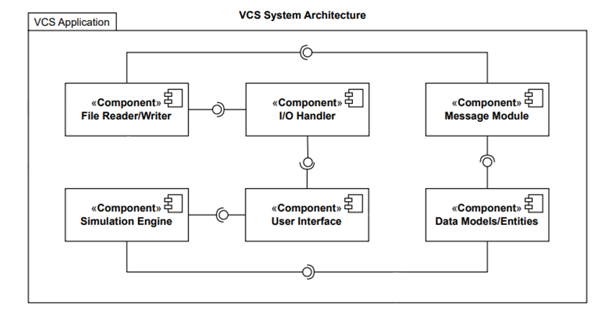

5.2 Views

5.2.1 Logical View

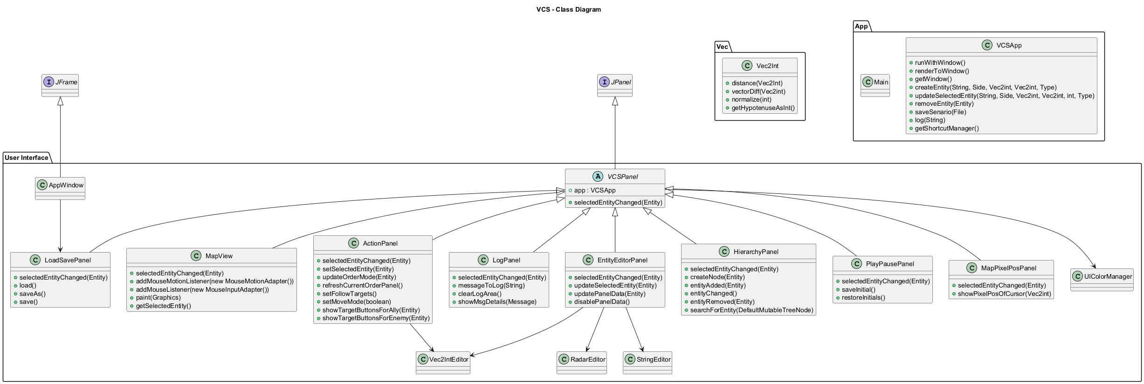

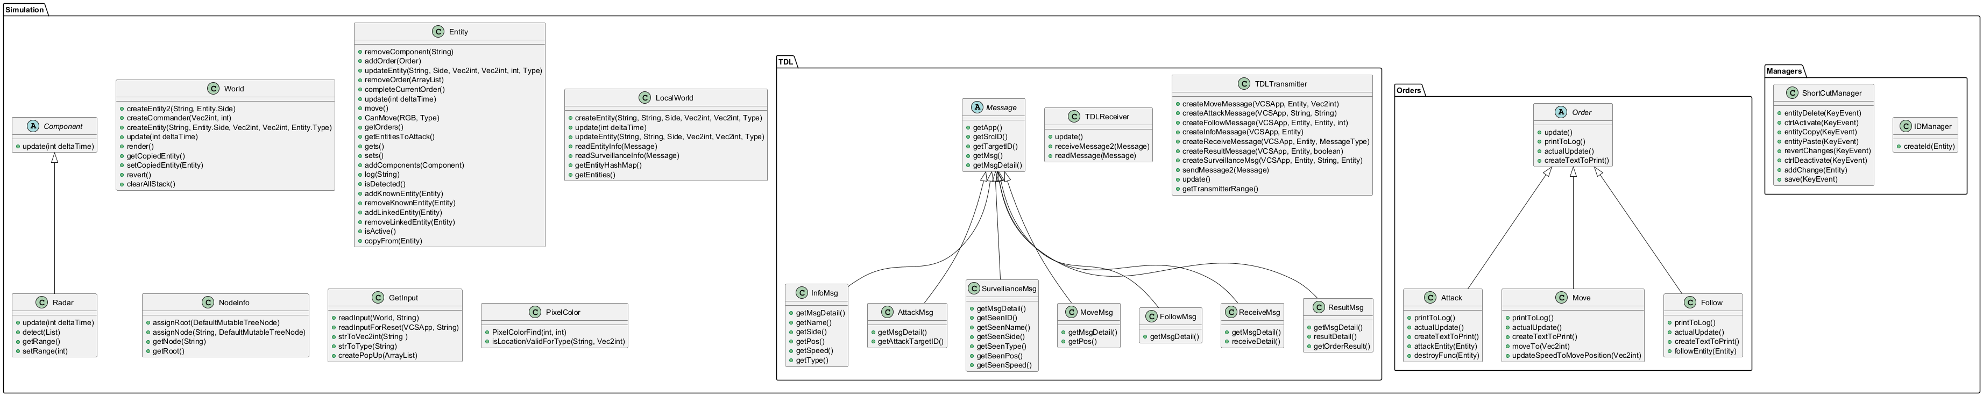

5.2.2 Process View

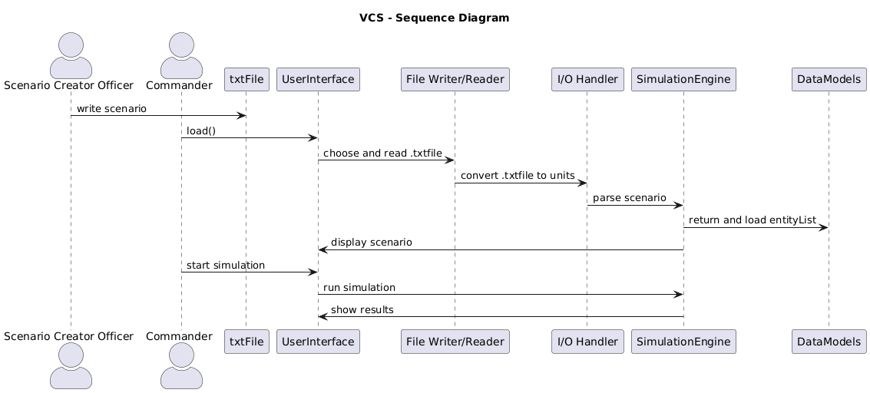

5.2.3 Deployment View

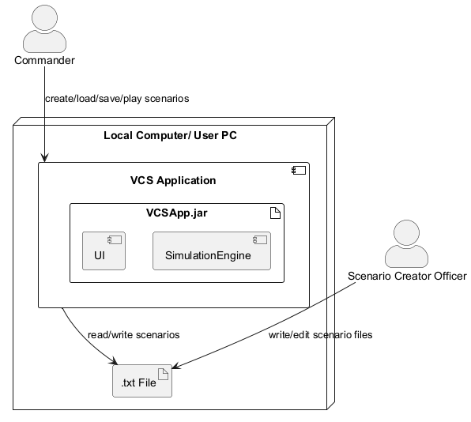

Ch6: Implementation & Test

6.1 Implementation
The software is developed with Java language and for the interface, Java Swing libraries are used with IntelliJ idea. As the development approach, Entity Component System was chosen and applied during the implementation.
Due to the content of the project, the main function has a loop that operates as a game engine. The update interval is determined as 1 second to avoid performance issues, and all the operations are running on these intervals. This loop is responsible for initializing the interface panels, checking and processing for inputs and rendering the results (see Appendix A).
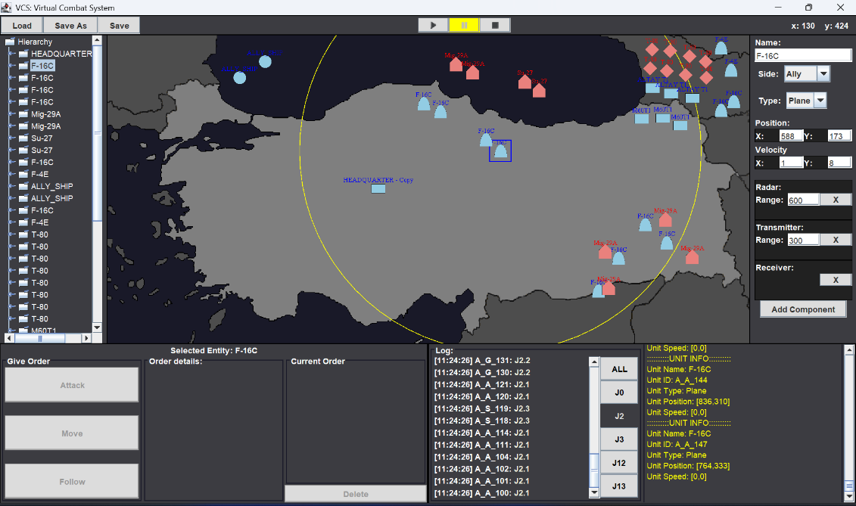
Core Features and Panels:
- Map Panel: The simulation plays on the Türkiye map and users are able to create new units by choosing the type and side through the right-click menu. There are 2 sides as “Ally” and “Enemy”, and 3 types of units as “Tank”, “Plane” and “Ship”. Left-clicking on a unit selects it, and after selection user can delete or copy the entity by pressing BACKSPACE & DELETE and CTRL+C buttons, and paste the entity with CTRL + V, also pressing CTRL + Z stands for a revert operation and it reverts the last change done on the units.

- Editor Panel: After selecting a unit, users are able to change the details about selected entity on the editor panel which is located at the right of the screen. Also, new components can be added and existing components can be modified or deleted through this panel.

- Hierarchy Panel: All units and their details are listed as a tree on the hierarchy panel at the left side of the screen.

- Action Panel: Users are able to give orders to selected entity on the action panel. There are 3 types of order as attack, move and follow. In the first section, users choose the type of the order. In the second one, user should choose the attack target, move point or follow target according to the choice that made on the first section. The right most section includes the order queue, and user can delete any order from the queue. The order system is integrated with the message system and to give an order to a unit, that unit should be in a link in the TDL network and should include a communication with HQ.
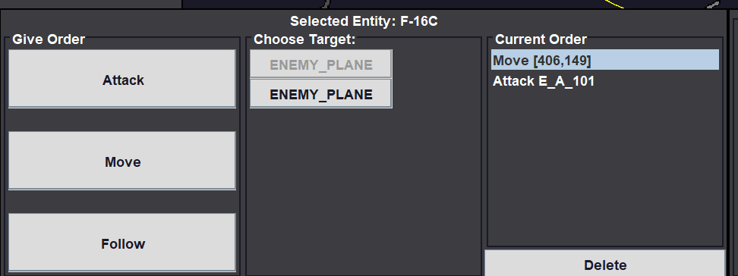

- Log Panels: This section includes message logs and debug logs in 2 separate panels. Message log panel provides information about TDL communication occurred during the runtime and shows the details about the TDL messages. The messages are listed with their time information and double clicking to a message opens a message window to show the detail about it. Also, selecting a message type applies a filter to logs and shows the selected message type only. The debug log section shows the debug of the engine and the events.

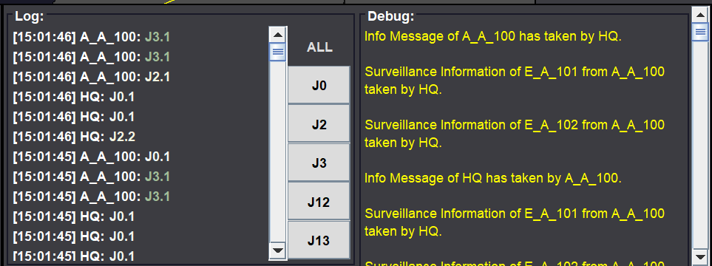
- Save & Load Scenario: Users can load a scenario or save the current scene in a txt format.
- Time Control: By using the media buttons, user can start playing the scenario, pause it when running or reset to the initial scene.
- Movement of Units: The ground types of areas in the map are defined as land and sea, and all units make their movements according to the constraints of their appropriate areas. While planes are capable of moving freely on the map, the movement of ships and tanks are limited with sea and land borders.
- TDL: The communication between units is occurring through their TDL capabilities. As a component, units can have transmitter and receivers, and by using these components they can transmit messages to the world and also receive messages according to their range. The details and code numbers of the messages can be accessible through the log panel.

6.2 Test
In this section, describe and discuss your test procedures (unit tests, integration tests, system tests such as performance tests) and plans. Explain the types of testing employed at each step of the development.
You should give details about your testing plans, testing procedures and testing results. You should describe the testing purposes as well such as HCI testing, Performance testing etc. You may design some Alpha and Beta testing procedures.

Ch7: Evaluation
Give a general evaluation (performance, problems and so on) of your system.

Ch8: Impact of the Project & Compliance with the Constraints

8.1 Compliance with the Realistic Constraints
Your project may have some realistic constraints (cost, cost effectiveness, runtime and memory constraints, performance and so on). Some of these have already been mentioned in your SRS documents (I hope). Discuss here, whether these constraints are met or not. You may also discuss the new constraints you’ve encountered during the development and implementation (runtime problems, memory problems and so on). After the discussion, summarize your findings by filling out the appropriate boxes in the table below. Enter NA if an item does not apply to your project.
Table 8.1 Realistic Constraints & Conditions
Economic Factors | Please specify/explain realistic constraints and conditions (type, use, amount, etc.)
EXPENDITURES
Computer
Other Devices
Peripherals
Internet Connection
Software
Textbook/Magazine/Support Material
Human Resources
Other
FUNDING Sources
University Resources
Project support (SANTEZ, TÜBİTAK, and so on)
Support by the Industry
Self-funded
Other sources
OTHER CONSTRAINTS
Memory
Runtime efficiency
MANAGERIAL
Schedule (time)

8.2 Impact of the Project
Here, discuss the impact of your project on the society, health and environment. After a short discussion on these enter your views and points into the table below as appropriate. If an item is not applied to your project just say NA.
Table 8.2 Impact Assessment Report
Professional/Ethical Issues | Please specify/explain (existence of items, violation of items, awareness about items)
ETHICS/IT Law | Are there any applicable laws or legislation that will be relevant to the use and/or the construction of the system you are building? How have you addressed them?
Copyright in copying multimedia (sound, video, text)
Use of licensed software
Data Privacy
Use of patented products/ideas
IT Laws in Turkey (5661 and others)
IT Laws - International
Plagiarism
PROFESSIONAL |  | Liability/Sustainability Issues – What is the potential for liability either to yourself or your customer or users of the system, if it is misused or has flaws? Financial Impact – Have the financial costs of deploying and supporting the system been fully evaluated for yourself, the customer, users, and society as a whole?
Sustainability (use of Licensed and/or open source code)
Maintenance
Liability
Financial impact/Manufacturability
SOCIAL/POLITICAL/  ENVIRONMENTAL | Societal Issues – What is the potential for this system to be beneficial or detrimental to society as a whole? What have you done to address the potentially detrimental use? Are there any side-effects on the environment? Are there any potential political implications of the use of your system? What impact will this system have on the intended user community? Have you taken steps to safeguard the interests of that community?
Political impact
Impact on health
Gambling
Pornography
Equal Access/equity
Environmental impacts (energy, carbon footprint and so on)
Technology acceptance & Human/Business psychology
Security issues
PROFESSIONAL (CODES, STANDARDS, FRAMEWORKS) | What technical standards are relevant to the software system you have built? How have you ensured conformance? These could be government standards, industry standards, or even just conventions that are followed in the market for your system. Be sure to clearly identify what type of standard you are talking about and who is the relevant authority for the standard.
IEEE
ISO
ANSI
TSE
ITIL/COBIT
OTHER

Ch9: Conclusions
In this Chapter, give a short summary, findings, and results of your Project.
The contribution of your project to the society to help to manage the problem that you have discussed at the beginning of the project and aimed to address.

Appendix A
The main loop:
public void runWithWindow() throws InterruptedException, InvocationTargetException {
uiColorManager = new UIColorManager();
world = new World(this);
window = new AppWindow(this);
mapView = new MapView(this);
editorPanel = new EntityEditorView(this);
hierarchyPanel = new HierarchyView(this);
logPanel = new LogPanel(this);
actionPanel = new ActionPanel(this);
playPausePanel = new PlayPausePanel(this);
loadSavePanel = new LoadSavePanel(this);
mapPixelPosPanel = new MapPixelPosPanel(this);
pixelColor = new PixelColor(this);
shortcutManager = new ShortcutManager(this);
idManager = new IDManager();

JPanel mergeSouthPanel = new JPanel(new GridLayout(1,2));
mergeSouthPanel.add(actionPanel);
mergeSouthPanel.add(logPanel);
mergeSouthPanel.setBackground(uiColorManager.TOP_BAR_COLOR);
actionPanel.setBorder(BorderFactory.createLineBorder(uiColorManager.DARK_TITLE_COLOR_1,2));
logPanel.setBorder(BorderFactory.createLineBorder(uiColorManager.DARK_TITLE_COLOR_1,2));

JPanel mergeNorthPanel = new JPanel(new BorderLayout());
mergeNorthPanel.add(loadSavePanel, BorderLayout.WEST);
mergeNorthPanel.add(playPausePanel, BorderLayout.CENTER);
mergeNorthPanel.add(mapPixelPosPanel, BorderLayout.EAST);
mergeNorthPanel.setBackground(uiColorManager.TOP_BAR_COLOR);
EmptyBorder eBorder = new EmptyBorder(4,4,4,4);
mergeNorthPanel.setBorder(eBorder);
mergeNorthPanel.setBorder(BorderFactory.createLineBorder(Color.BLACK,2));

int targetWidthNorth = Toolkit.getDefaultToolkit().getScreenSize().width;
int targetHeightNorth = Toolkit.getDefaultToolkit().getScreenSize().height / 26;
mergeNorthPanel.setPreferredSize(new Dimension(targetWidthNorth, targetHeightNorth));

JScrollPane hierarchyScroll = new JScrollPane(hierarchyPanel.tree);
hierarchyScroll.getViewport().setBackground(uiColorManager.DARK_PANEL_COLOR);
hierarchyScroll.setBorder(null);
hierarchyScroll.setVerticalScrollBarPolicy(JScrollPane.VERTICAL_SCROLLBAR_AS_NEEDED);
hierarchyScroll.setHorizontalScrollBarPolicy(JScrollPane.HORIZONTAL_SCROLLBAR_AS_NEEDED);
hierarchyScroll.setVerticalScrollBar(new JScrollBar(Adjustable.VERTICAL,0,0,0,0));
hierarchyScroll.setHorizontalScrollBar(new JScrollBar(Adjustable.HORIZONTAL,0,0,0,0));

hierarchyPanel.add(hierarchyScroll);

JScrollPane editorScroll = new JScrollPane(editorPanel);
editorScroll.getViewport().setBackground(uiColorManager.DARK_PANEL_COLOR);
editorScroll.setBorder(null);
editorScroll.setVerticalScrollBarPolicy(JScrollPane.VERTICAL_SCROLLBAR_NEVER);
editorScroll.setHorizontalScrollBarPolicy(JScrollPane.HORIZONTAL_SCROLLBAR_NEVER);
editorScroll.setVerticalScrollBar(new JScrollBar(Adjustable.VERTICAL,0,0,0,0));
editorScroll.setWheelScrollingEnabled(false);
window.add(editorScroll, BorderLayout.EAST);

window.add(mapView,BorderLayout.CENTER);
window.add(hierarchyPanel, BorderLayout.WEST);
window.add(mergeSouthPanel, BorderLayout.SOUTH);
window.add(mergeNorthPanel, BorderLayout.NORTH);
window.setVisible(true);

headQuarter = world.createCommander(null, 200);
hierarchyPanel.entityAdded(headQuarter);
window.setFocusable(true);
window.requestFocus();

SwingUtilities.invokeLater(new Runnable() {
@Override
public void run() {
int delta = 1000; // 1000
mapView.initializeTheMap();

simTimer = new Timer(delta, new AbstractAction() {
@Override
public void actionPerformed(ActionEvent e) {
world.update(delta);
world.processSendList2();
pixelColor.update(delta);
hierarchyPanel.update(delta);
editorPanel.update();
actionPanel.update();

for(Entity ent : world.entitiesToRemove){
world.entityHashMap.get(ent.getId()).setActive(false);
world.unregisterReceiver(((TDLReceiverComp) ent.getComponent(Component.ComponentType.RECEIVER)));
}
world.entitiesToRemove.clear();
renderToWindow();
}
});
}
});
}

References
Bollini, L. (2017). “Beautiful interfaces. From user experience to user interface design”, The Design Journal, Vol.20, No.1.
Ehrlich, J. (2013). The Component Entity System for Virtual Environments. Macomb, Illinois, US: School of Computer Sciences, Western Illinois University.
Gallagher, S. (2021). “The history of the connected battlespace, part one: Command, control, and conquer”, Retrieved November 5, 2025, from https://arstechnica.com/information-technology/2021/01/connected-battlespace-1/
Ganiyu, A.A., Adesina, A.O. & Aderounmu, A.A. (2010). “The use of Java Swing’s components to develop a widget”, International Journal of Human Computer Interaction (IJHCI), Vol.1, No.4, pp. 1–10.
Marner, J. (2002). Evaluating Java for Game Development. Copenhagen, Denmark: Department of Computer Science, University of Copenhagen.
Oracle (2025). “Building a User Interface”, Retrieved November 6, 2025, from https://www.oracle.com/java/technologies/jpl1-building-userinterface.html
Stoica, A., Militaru, D., Moldoveanu, D. & Popa, A. (2016). “Tactical Data Link – from Link 1 to Link 22”, Scientific Bulletin of Naval Academy, Vol.19, No.2.
Suryana, J., & Candra, D. (2019). “Implementation of Link-16 based Tactical Data Link system using software-defined radio”, International Conference on Electrical Engineering and Informatics (ICEEI), Indonesia, July 2019, pp. 555–559.
Webster, C. (2015). “Entity component systems usefulness, literature review”, Journal of Latex Class Files, Vol.14, No.8.

